**In-Class Assignment 17**

1. The fuel efficiency of a set of 25 cars is calculated to have a mean value of 22.3 mpg with a standard deviation of 5. We want to determine whether this value is statistically different from 20.09 mpg, the mpg value in the mtcars dataset, at the 95% confidence level.

(a) State the null hypothesis. Is it one-sided or two-sided?

The null hypothesis is - The mean of mpg in the cars data set is equal to 20.09. The hypothesis is two sided.

(b) Determine whether the null hypothesis is or is not falsified, by a Monte Carlo simulation with 100,000 runs. What is the p-value? Compare your result to what you got last Tuesday.



The null hypothesis is falsified as p value is less than 0.05, The p-value is approximately equal to what we got last time.

2. A set of sample data follows an exponential distribution. The set has 750 samples with a mean value of 30. Perform a hypothesis test with simulation (10,000 runs) to determine whether the mean value is 95% likely to be greater than 28.

The null hypothesis is - The mean value is less than or equal to 28. The hypothesis is one sided.

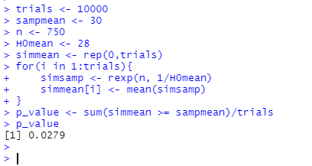

The null hypothesis is falsified as the p value is less than 0.05